Experiment 7: FTP Server

Step 1 » Update repositories .
sudo apt-get update

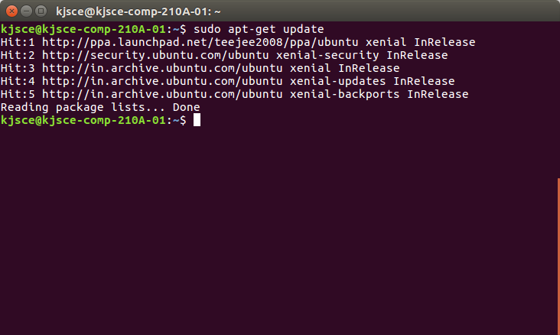
Step 2 » Install VsFTPD package using the below command.
sudo apt-get install vsftpd

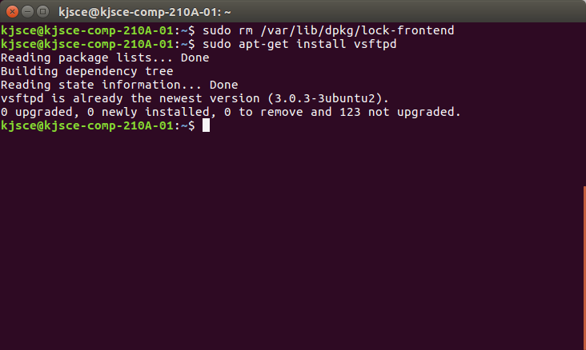
Step 3 » After installation open /etc/vsftpd.conf file and make changes as follows.
Uncomment the below lines (line no:29 and 33).

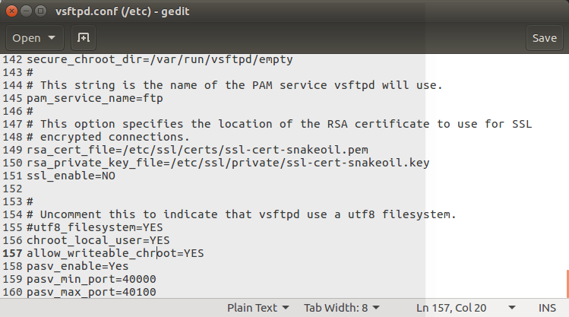
Step 4 » Restart vsftpd service using the below command.
sudo service vsftpd restart

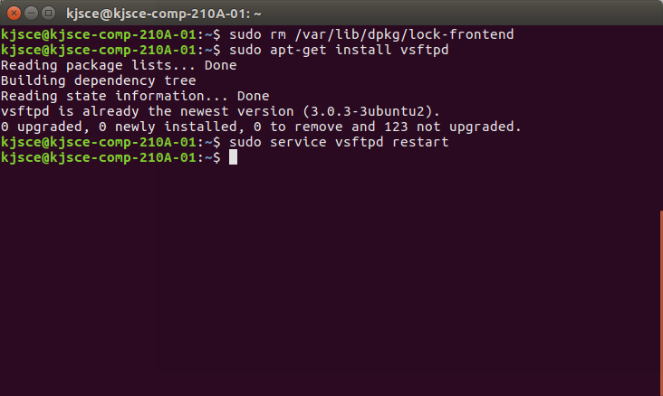

Step 5 » Create user with the below command. Ftp server will listen on port 21.
Use shell to prevent access to the bash shell for the ftp users .

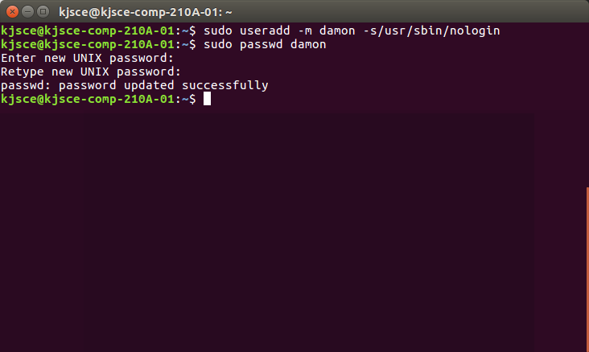
Step 6 » Allow login access for nologin shell .
Open /etc/shells and add the following line at the end.
/usr/sbin/nologin
SFTP is called as “Secure FTP” which generally use SSH File Transfer Protocol . so we need openssh-server
package installed , Issue the below command if it’s not already installed.
sudo apt-get install openssh-server

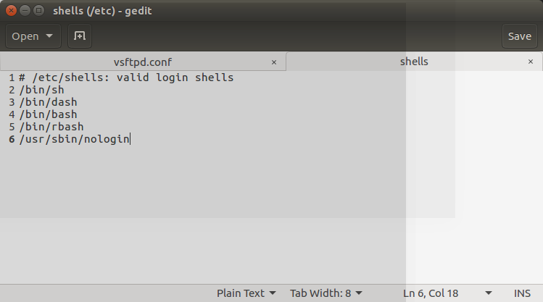

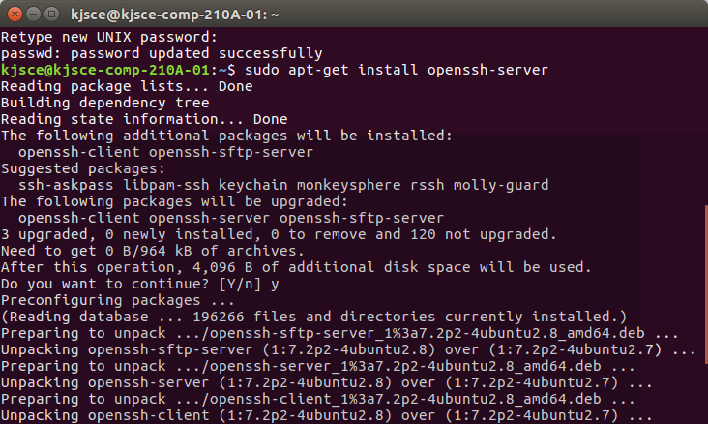
Step 7 » Create a new group ftpaccess for FTP users.
sudo groupadd ftpaccess

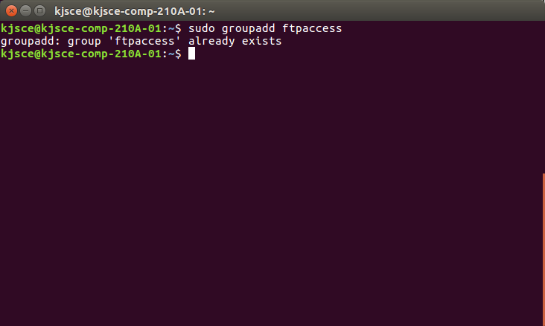
Step 8 » Now make changes in this /etc/ssh/sshd_config file.
» Find and comment the below line
Subsystem sftp /usr/lib/openssh/sftp-serverand
Add these lines at the end of the file.
Subsystem sftp internal-sftp
Match group ftpaccess
ChrootDirectory %h
X11Forwarding no
AllowTcpForwarding no
ForceCommand internal-sftp

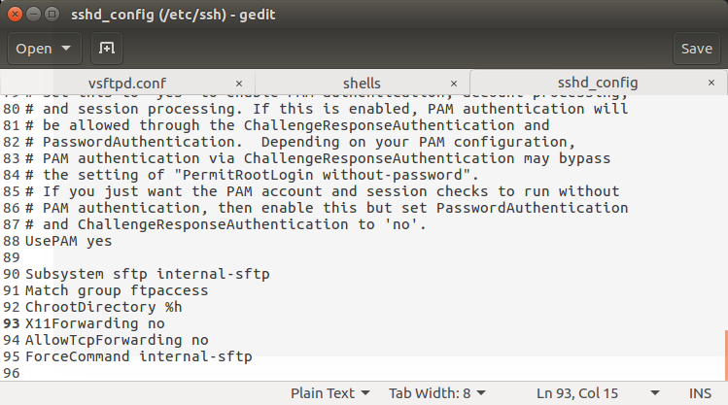
Step 9 » Restart sshd service.
sudo service ssh restart

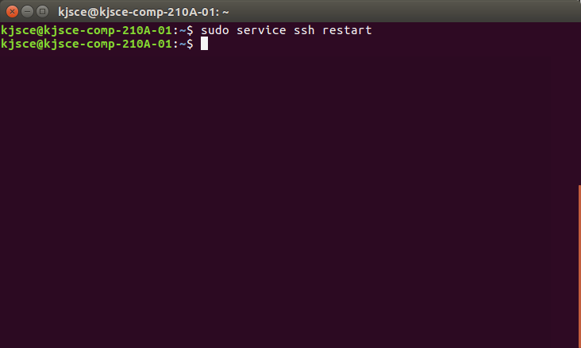
Step 10 » creating Users for sftp access.
Create user john with ftpaccess group and /usr/bin/nologin shell.
sudo usermod -m john -g ftpaccess -s /usr/sbin/nologin

sudo passwd john
Change ownership for the home directory.
sudo chown root /home/john
Create a folder inside home directory for writing and change ownership of that folder.
sudo mkdir /home/john/www
sudo chown john:ftpaccess /home/john/www

sudo usermod john -g ftpaccess -s /usr/sbin/nologin
sudo chown root /home/john
sudo mkdir /home/john/www
sudo chown john:ftpaccess /home/john/www
Now john can able to upload files to www folder using FTP as well as SFTP.

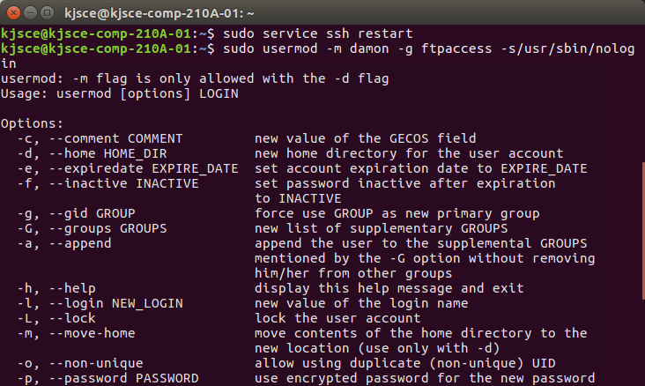

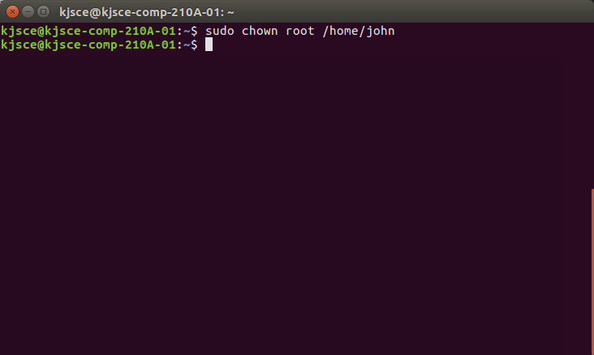
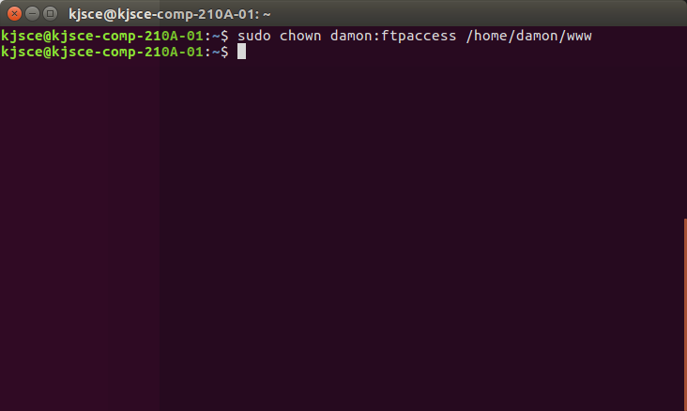
Testing FTP:
To Test FTP server on Ubuntu 14.04(vsftpd ),need to run the following command:

1. Internet File Transfer Program:
It does connect to transfer files to and from a remote network ftp site. One must aware ftp
username and password for user-based password authentication or with anonymous user
access .
a. ftp ftp.example.com
b. ftp 1.2.3.4
c. ftp user@ftp.example.com
d. ftp ftp.freebsd.org

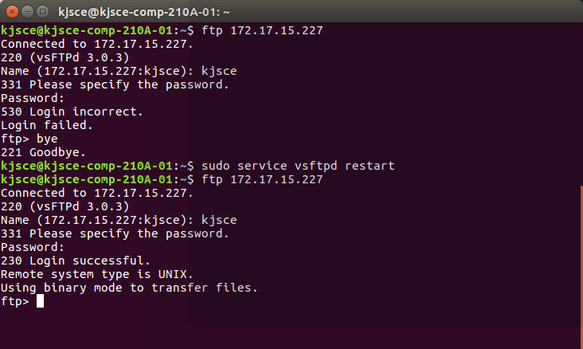

2. List Current File:
This command list the names of the files in the current remote directory
ftp&gt; ls

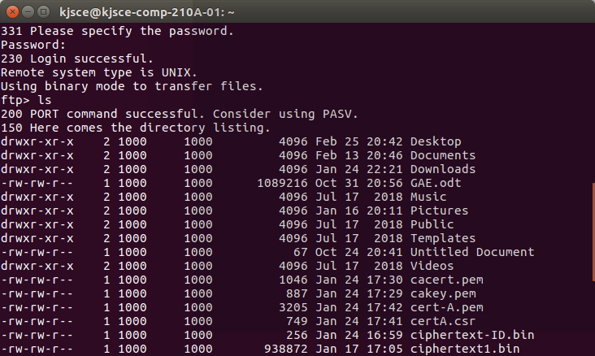
3. Change Directory:
To change directory on the remote machine use cd command:

K. J. Somaiya College of Engineering, Mumbai-77

(Autonomous College Affiliated to University of Mumbai)

EMBED
Word.Picture.
8

5 Department of Computer Engineering Open Source Lab - Jan-May
2019
ftp&gt; cd dirName
Example : To change to pub directory, enter:

ftp&gt; cd pub

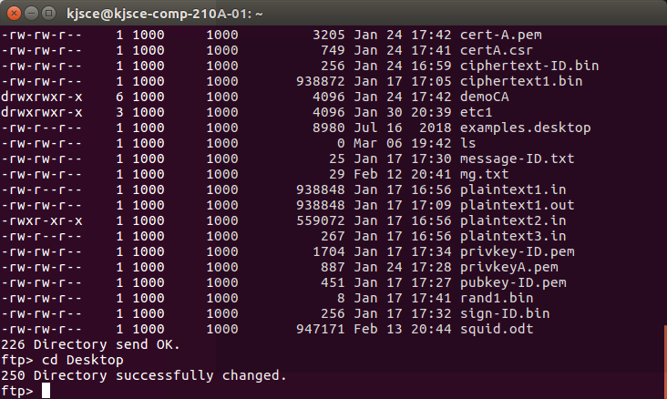
4. Download / Copy file:
a. Download / Copy file o copy one file at a time from the remote ftp server to the local
system use get command:
i. get fileName
ii. get fileName newFileName
b. In this example, download file resume.pdf in the current remote directory to (or on top
of) a file with the same name, resume.pdf, in your current local directory:
i. ftp&gt; get resume.pdf

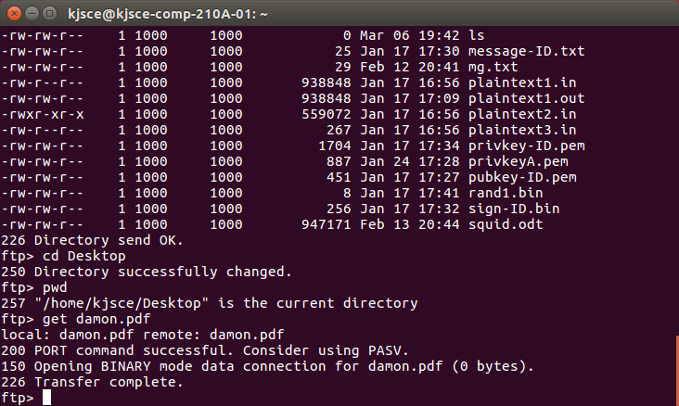
5. Change Local Directory:

(a) To change directory on your local system:
1. ftp&gt; lcd /path/to/new/dir
2. ftp&gt; lcd /tmp

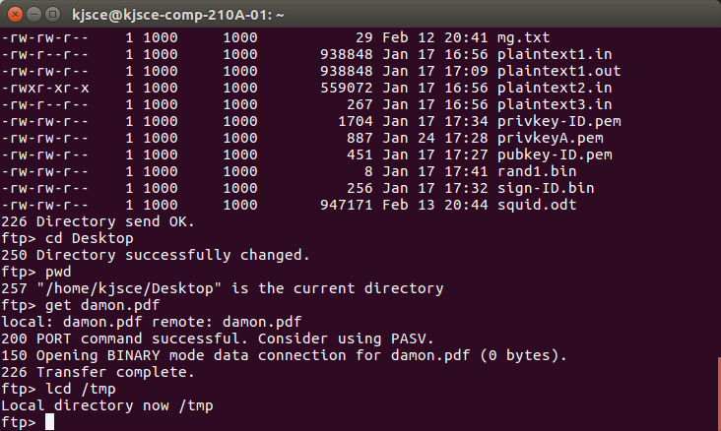
(b) Print local directory:
(i) The lpwd command prints current download directory for local systems
1. ftp&gt; lpwd

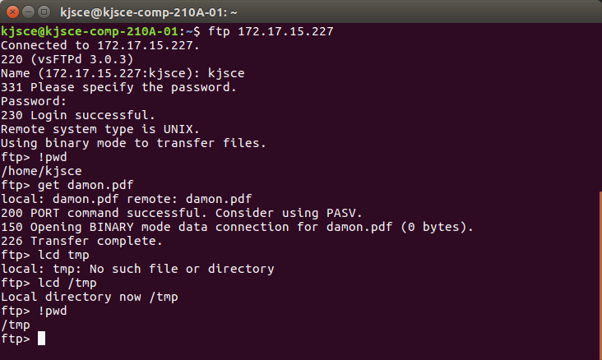
(c) pwd: To find out the pathname of the current directory on the remote ftp server,
enter:
ftp&gt; pwd

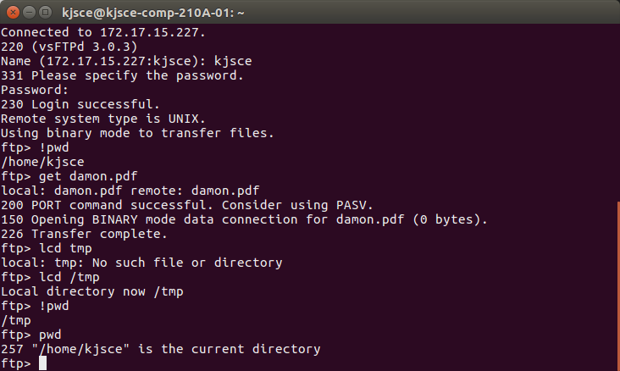
6. Download Multiple Files:
i) To copy multiple files from the remote ftp server to the local system.
ftp&gt; mget *

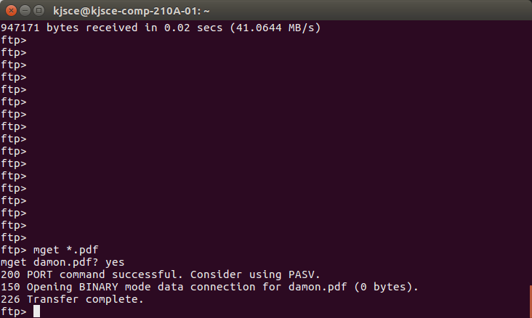
ii) To download all perl files (ending with .pl extension)
ftp&gt; mget *.pl

7. Turn On / Off Interactive Prompting:

The ftp command prompt sets interactive prompting; “on” which enables prompting so that you
can verify of each step of the multiple commands, “off” allows the commands to act unimpeded.
ftp&gt; prompt on
ftp&gt; mput *.php
ftp&gt; prompt off
ftp&gt; mget *.py

